**Usage of JIRA Software**

|  |  |
| --- | --- |
| Date | 29 October 2022 |
| Team ID | PNT2022TMID40750 |
| Project Name | Inventory Management System for  Retailers |
| Maximum Marks | 2 Marks |

**Creating the issue(Backlog) for the project:**

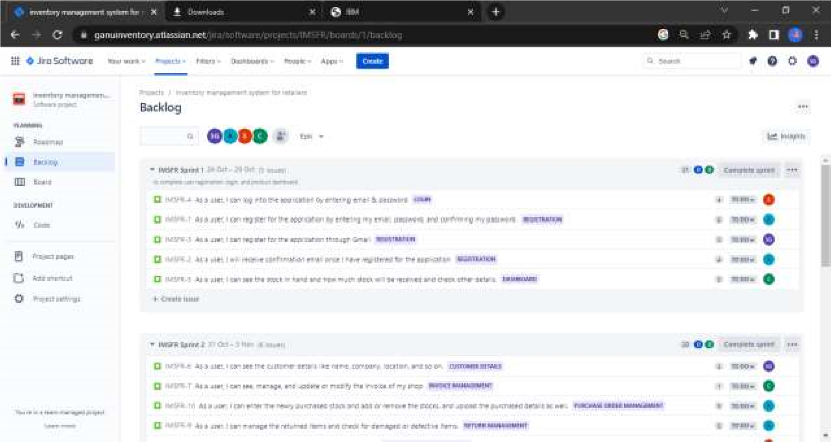

**Roadmap for the project:**

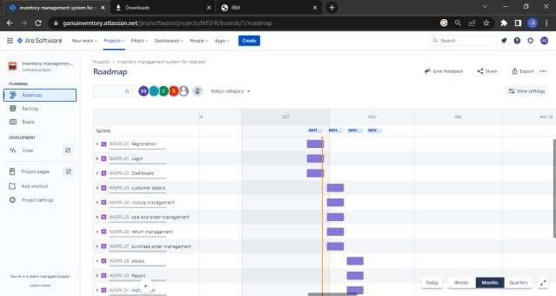

**Creating the board to the sprints for the project:**

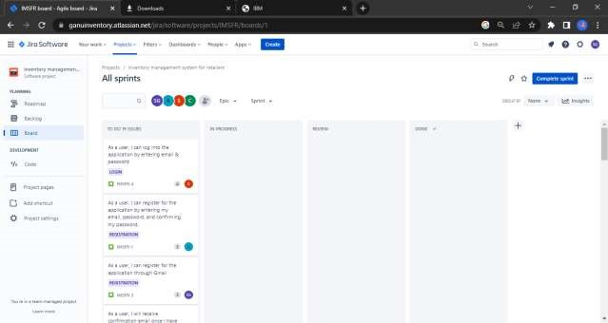

**Burndown for the project:**

